**APPLICATION OF GEOGRAPHICAL INFORMATION SYSTEM IN LIVESTOCK INDUSTRY IN MALAYSIA FROM YEAR 2010 TO 2020**

**FAKHRULISHAM, R.*,** SHARIL AZWAN, M. Z., MASRIN, A., AND FARID ZAMANI, C. R.

Veterinary Research Division, Department of Veterinary Services, Ministry of Agriculture and Food Industries, Wisma Tani, Podium Block, 4G1, Precinct 4, 62630 Putrajaya.

*Corresponding author: [fakhrul@dvs.gov.my](mailto:fakhrul@dvs.gov.my)

ABSTRACT

The Geographical Information System (GIS) evolves and transforms each decade along with the GIS technology and its capabilities. It would continue to evolve and transform to keep up with the new technology. This study is aimed to provide an overview of the application of GIS on environment, diseases monitoring, farm management and environment in the Malaysian livestock industry, specifically for the Department of Veterinary Services (DVS) from 2010 to 2020.

…

Keywords: GIS, livestock, Web-GIS, disease mapping, precision farming

**INTRODUCTION**

Geographic Information Systems (GIS) is often used to access, manipulate, and analyse spatial data (Malaysia National Geospatial Centre, 2021). The GIS was previously used to fulfil the government’s need in the focus area of land and farm management, urban planning, population census, surveying, and mapping. The change of software from silo stand alone to sharing capability and crowd sourcing allows the data information to grow faster and spread wider.

…

**MATERIALS AND METHOD**

…

**RESULTS AND DISCUSSION**

GIS work has also been used in the process of redevelopment of the Kaprima Farm. In 2015, a total of 8 Kaprima Farms in Terengganu were offered to successful entrepreneurs for farm redevelopment. However, there were constraints in determining the specific area to mark the offering area, as well as to indicate current facilities, buildings and the geographical condition within the farm perimeter. GIS is widely accepted around the world and transformed from a research-dominated to a user-dominated.

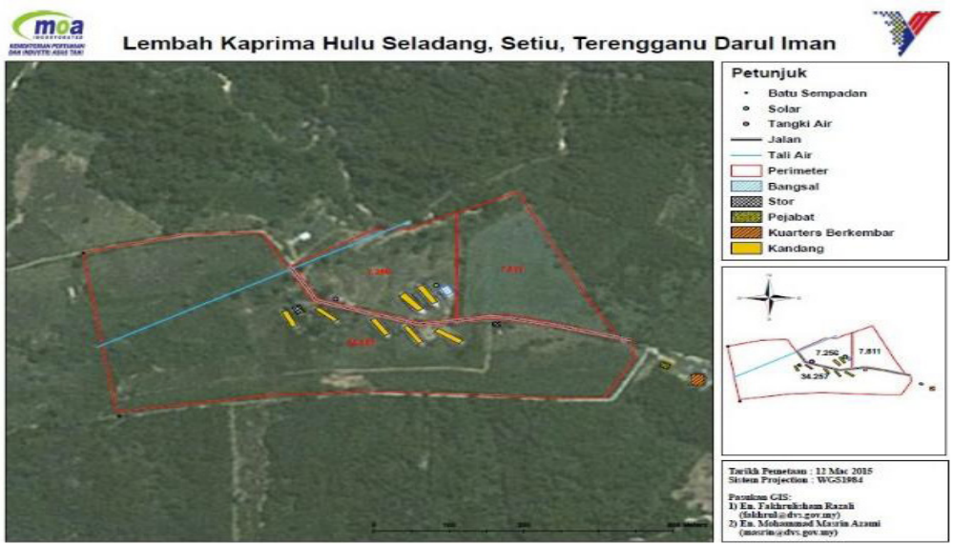

Figure 1. Lembah Kaprima Farm at Setiu Terengganu. This map provides information on coordinates, road lengths, perimeter, and farm features.

….

Table 1. Number of public complaints on the occurence of the fly disturbance for year 2016 to 2018.

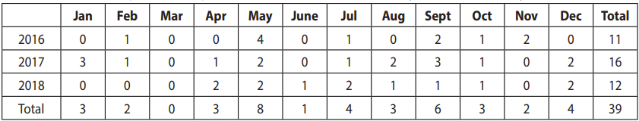

…

**CONCLUSION**

Uncontrolled and unethical use of GIS could raise concern in country’s security and privacy. Thus, DVS Malaysia should invest and keep up with current technology to safeguard its sovereignty in the future. It is hoped that this paper provides valuable information for further investigations.

…

**ACKNOWLEDGEMENT**

…

**REFERENCES**

1. Masrin A., Nurul Fatiha A.S., Fakhrulisham R. And Sharil Azwan M.Z. (2018). Geomapping On Seropositive Status Of Melioidosis Among Livestock In Malaysia From 2012 To 2016. MJVR. (9(2), 44-52
2. Senawi, J. (2012). Epidemiology of Foot and Mouth Disease in Cattle In Pahang, Malaysia. https://researchrepository.murdoch.edu.au/id/ eprint/10695/
3. Malaysia National Geospatial Centre, Ministry of Energy and Natural Resources (KeTSA) (2021) Geospatial Data. Retrieved from http:// www.mygeoportal.gov.my/faq?title=&field_ categories2_target_id=All&page=2